**What factors influence the abundance of photosynthetic proteins in leaves?**

**t**emperature and light environment determine abundance of leaf photosynthetic proteins in wild Eucalypts; a **quantitative, continental-scale ecological proteomics study**

Research questions:

1. How does photosynthetic protein abundance in leaves follow biogeographic gradients (temp, rainfall, soil chemistry)?

* Hypotheses (re: Hikosaka & Terashima 1995):
  + light environment
    - Photosystem complex proteins will be most abundant where leaf-level irradiance is lowest, and photosynthesis is light-limited
      * **Yes, in relative terms**

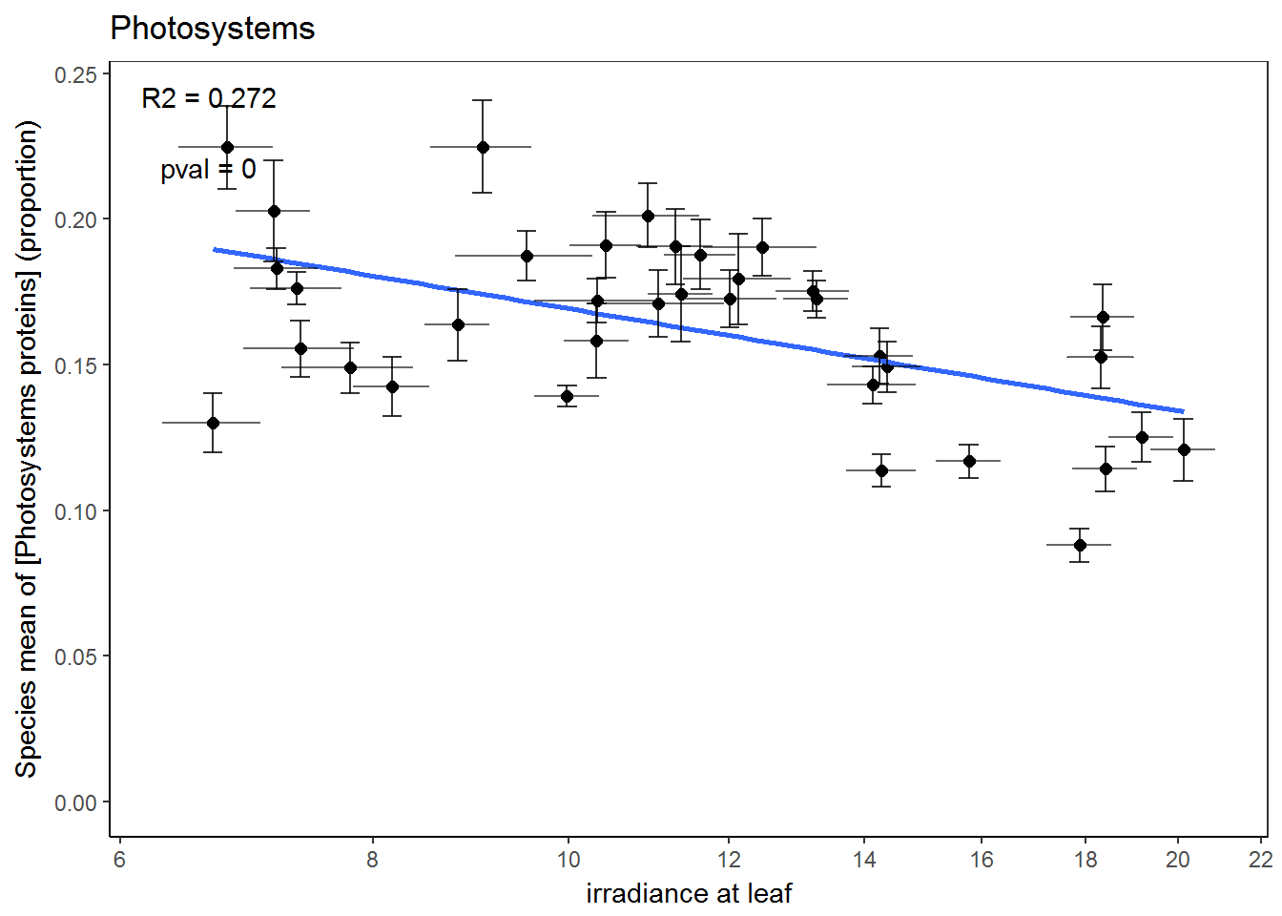

* + - * **Maintained on per area basis (i.e. it’s not just other protein groups going down)**
* Call:
* lm(formula = scale(mean) ~ scale(total_protein_mean) + scale(log(leafrad_mean)),
* data = data_means)
* Residuals:
* Min 1Q Median 3Q Max
* -1.26414 -0.35130 0.07683 0.38505 0.96346
* Coefficients:
* Estimate Std. Error t value Pr(>|t|)
* (Intercept) 9.803e-17 8.780e-02 0.00 1.00000
* scale(total_protein_mean) 7.502e-01 9.160e-02 8.19 1.87e-09 ***
* scale(log(leafrad_mean)) -2.784e-01 9.160e-02 -3.04 0.00461 **
* ---
* Signif. codes: 0 ‘***’ 0.001 ‘**’ 0.01 ‘*’ 0.05 ‘.’ 0.1 ‘ ’ 1
* Residual standard error: 0.5268 on 33 degrees of freedom
* Multiple R-squared: 0.7384, Adjusted R-squared: 0.7225
* F-statistic: 46.56 on 2 and 33 DF, p-value: 2.466e-10

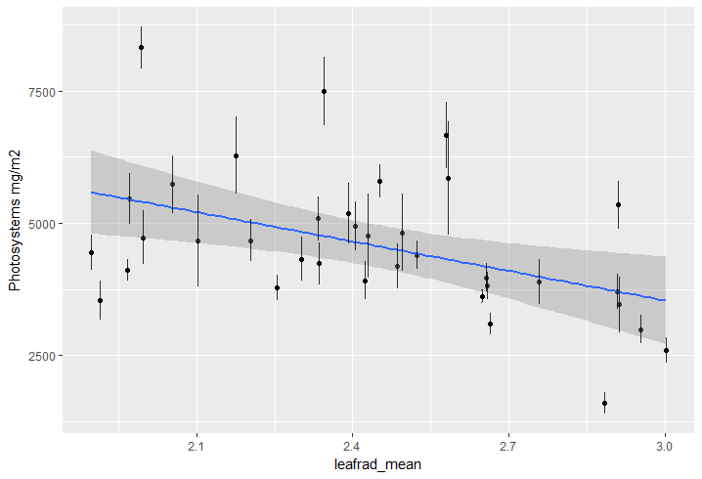

* Photosystem complex proteins will be most abundant where canopy gap fraction is lowest, and photosynthesis is light-limited
  + **Yeah, same as with irradiance**

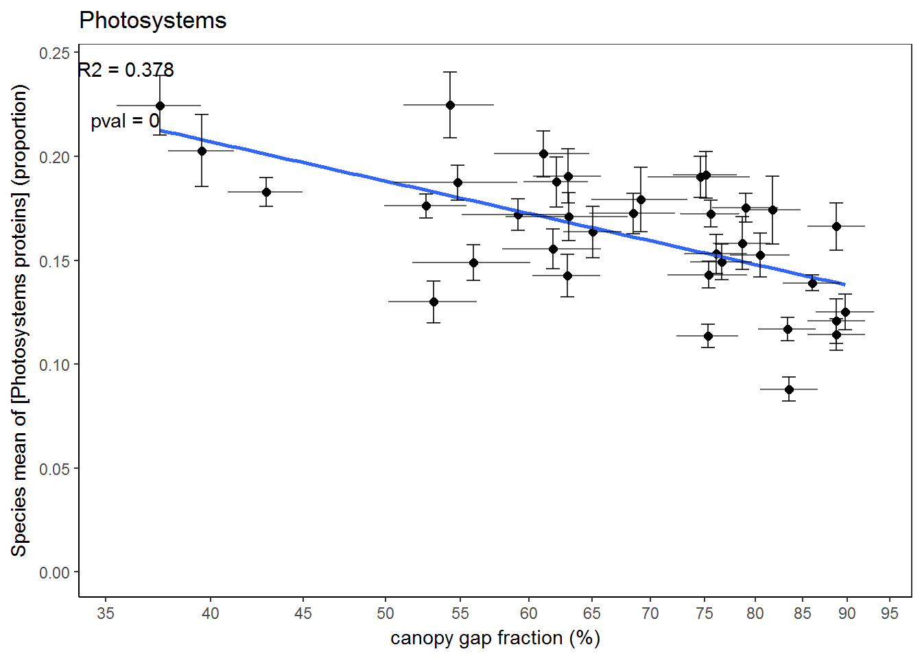

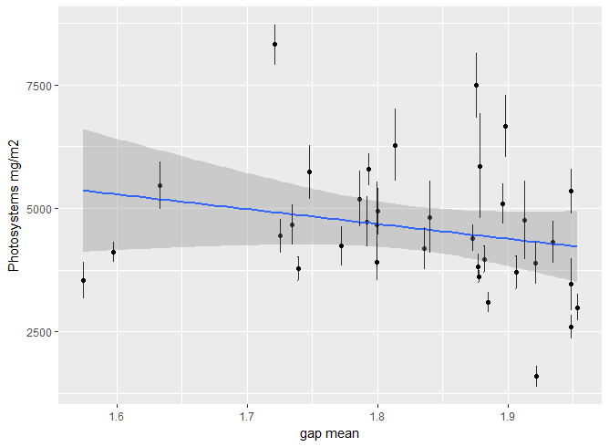

Call:

lm(formula = scale(mean) ~ scale(total_protein_mean) + scale(gap_mean),

data = data_means)

Residuals:

Min 1Q Median 3Q Max

-1.22771 -0.22082 0.00469 0.35613 1.04645

Coefficients:

Estimate Std. Error t value Pr(>|t|)

(Intercept) 3.311e-16 8.360e-02 0.000 1.000000

scale(total_protein_mean) 8.325e-01 8.491e-02 9.804 2.65e-11 ***

scale(gap_mean) -3.130e-01 8.491e-02 -3.686 0.000812 ***

---

Signif. codes: 0 ‘***’ 0.001 ‘**’ 0.01 ‘*’ 0.05 ‘.’ 0.1 ‘ ’ 1

Residual standard error: 0.5016 on 33 degrees of freedom

Multiple R-squared: 0.7628, Adjusted R-squared: 0.7484

F-statistic: 53.06 on 2 and 33 DF, p-value: 4.894e-11

* Calvin cycle enzymes will be more abundant in high light conditions, as they determine the rate of light-saturated photosynthesis (Farquar 1980) “The two major biochemical processes thought to limit photosynthesis are the carboxylation of ribulose-1,5-bisphosphate (RuBP) and electron transport photochemistry for the regeneration of RuBP in the Calvin cycle (Farquhar et al. 1980).”- Lin et al 2011 ‘Temperature responses of leaf net photosynthesis: the role of component processes’
  + - * **NO EVIDENCE THAT THIS EFFECT OCCURS INDEPENDENTLY OF TAVG**
* Call:
* lm(formula = scale(mean) ~ scale(total_protein_mean) + scale(log(leafrad_mean)),
* data = data_means)
* Residuals:
* Min 1Q Median 3Q Max
* -0.46759 -0.13489 0.00836 0.12855 0.34636
* Coefficients:
* Estimate Std. Error t value Pr(>|t|)
* (Intercept) 3.617e-16 3.613e-02 0.000 1.000
* scale(total_protein_mean) 9.870e-01 3.770e-02 26.184 <2e-16 ***
* scale(log(leafrad_mean)) 4.429e-02 3.770e-02 1.175 0.248
* ---
* Signif. codes: 0 ‘***’ 0.001 ‘**’ 0.01 ‘*’ 0.05 ‘.’ 0.1 ‘ ’ 1
* Residual standard error: 0.2168 on 33 degrees of freedom
* Multiple R-squared: 0.9557, Adjusted R-squared: 0.953
* F-statistic: 355.9 on 2 and 33 DF, p-value: < 2.2e-16

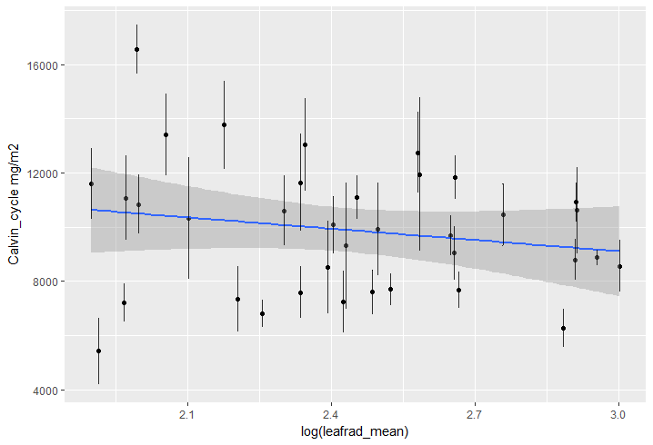

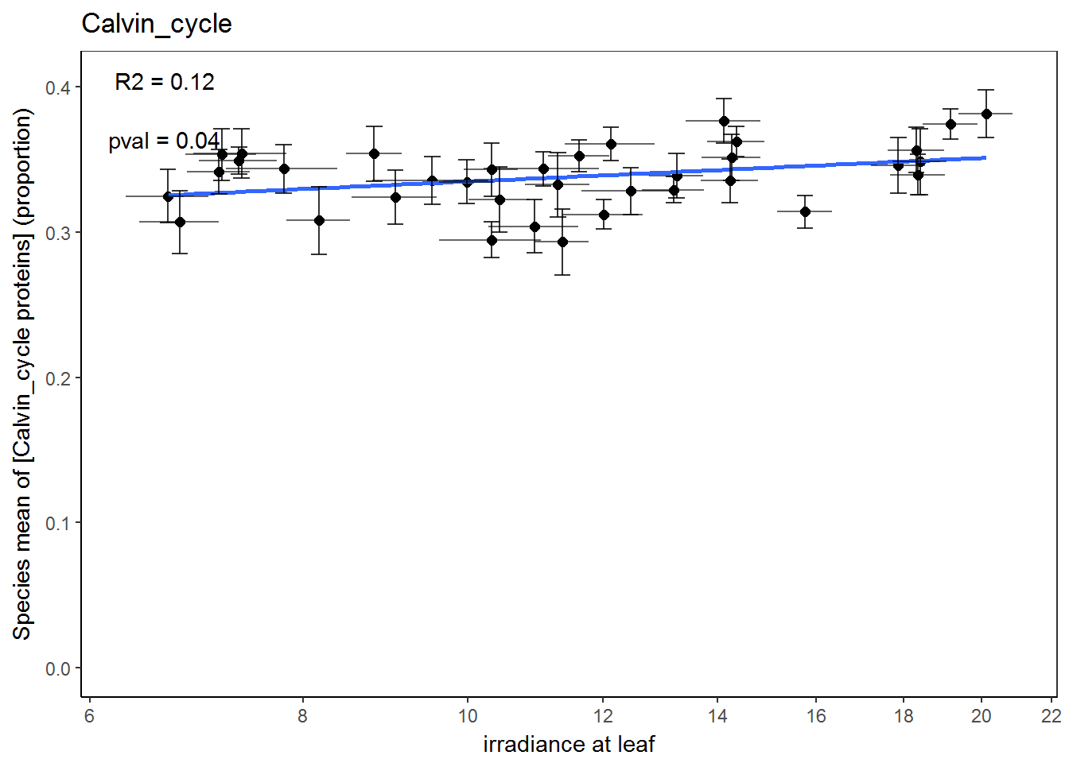

* Calvin cycle proteins will be most abundant at low rainfall, so as to effect greater Ci drawdown at lower time-averaged Gs.
  + - * **NO EVIDENCE**
* Call:
* lm(formula = scale(mean) ~ scale(total_protein_mean) + scale(log10(prec)),
* data = data_means)
* Residuals:
* Min 1Q Median 3Q Max
* -0.49365 -0.14367 0.04095 0.11150 0.36318
* Coefficients:
* Estimate Std. Error t value Pr(>|t|)
* (Intercept) 3.342e-16 3.619e-02 0.000 1.00
* scale(total_protein_mean) 9.602e-01 3.953e-02 24.291 <2e-16 ***
* scale(log10(prec)) -4.437e-02 3.953e-02 -1.122 0.27
* ---
* Signif. codes: 0 ‘***’ 0.001 ‘**’ 0.01 ‘*’ 0.05 ‘.’ 0.1 ‘ ’ 1
* Residual standard error: 0.2172 on 33 degrees of freedom
* Multiple R-squared: 0.9555, Adjusted R-squared: 0.9528
* F-statistic: 354.6 on 2 and 33 DF, p-value: < 2.2e-16

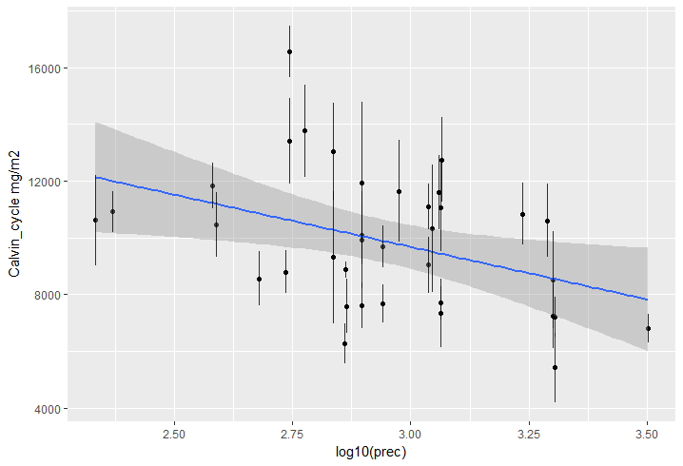

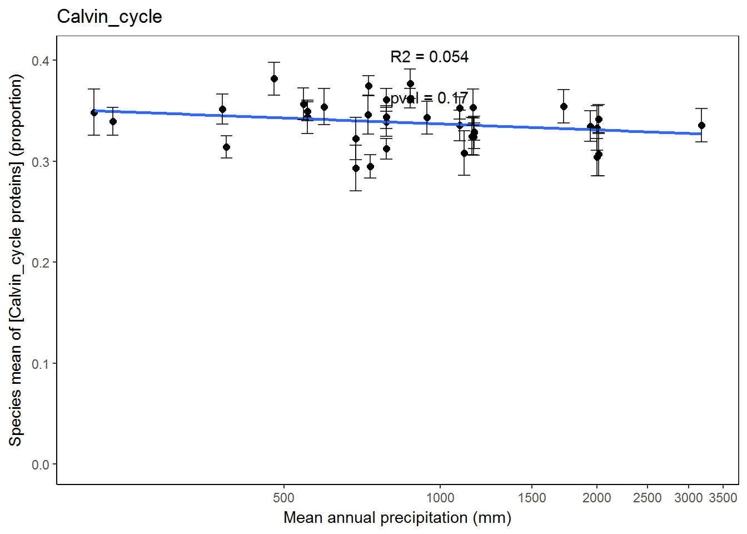

* Temperature:
  + Calvin cycle enzymes and electron transport proteins will be more abundant at lower temperatures, to counteract slow enzymatic reaction rates
    - * + **NO EVIDENCE IN RELATIVE DATA**
        + **Mg/m2: weak relationship**
        + **Calvin cycle protein amount v. strongly tracks total protein amount (R2 – 0.95!)**
* Call:
* lm(formula = scale(mean) ~ scale(total_protein_mean) + scale(tavg),
* data = data_means)
* Residuals:
* Min 1Q Median 3Q Max
* -0.46341 -0.09613 0.00272 0.12424 0.34734
* Coefficients:
* Estimate Std. Error t value Pr(>|t|)
* (Intercept) 3.310e-16 3.508e-02 0.000 1.0000
* scale(total_protein_mean) 1.042e+00 5.012e-02 20.797 <2e-16 ***
* scale(tavg) 9.325e-02 5.012e-02 1.861 0.0717 .
* ---
* Signif. codes: 0 ‘***’ 0.001 ‘**’ 0.01 ‘*’ 0.05 ‘.’ 0.1 ‘ ’ 1
* Residual standard error: 0.2105 on 33 degrees of freedom
* Multiple R-squared: 0.9582, Adjusted R-squared: 0.9557
* F-statistic: 378.4 on 2 and 33 DF, p-value: < 2.2e-16

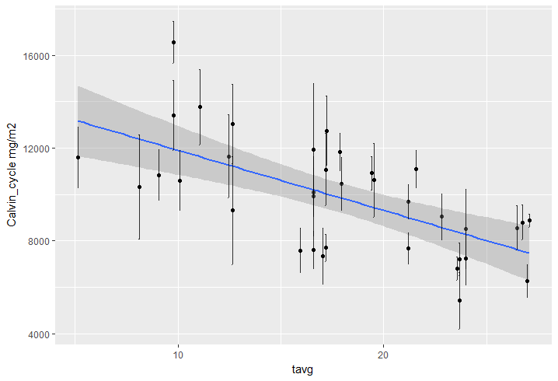

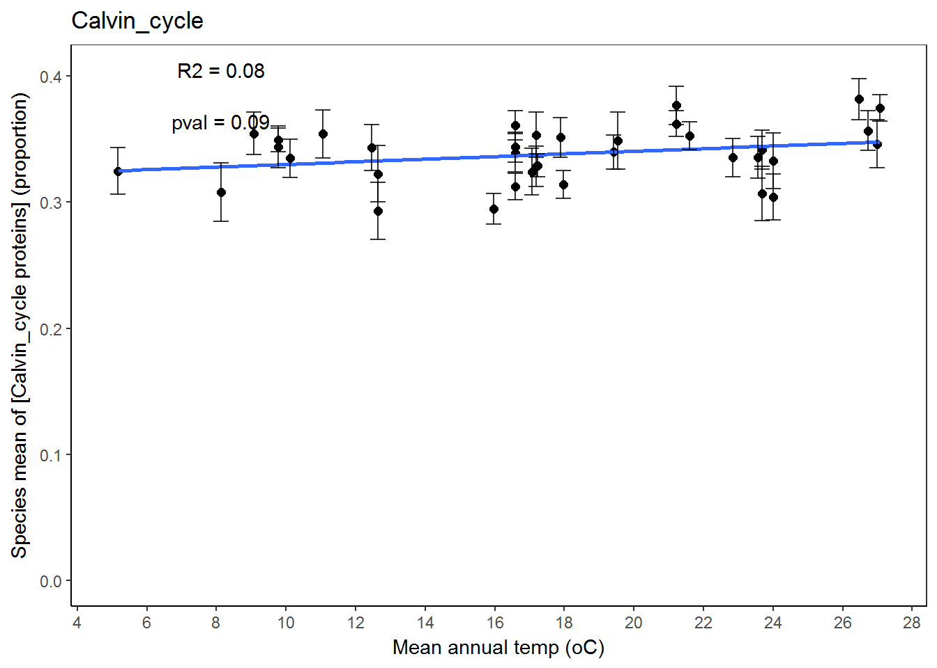

* + - * Alternative hypothesis is that leaf temperature is different enough from ambient temperature due to all the energy and gas fluxes associated with photosynthesis that there will be no effect here
      * The effect is slight.
* Photosystem complex protein abundance will not be affected by temperature as rate of photon capture is not meaningfully affected by leaf temperature
  + - * **Correct, in mg/m2**
* Call:
* lm(formula = scale(mean) ~ scale(total_protein_mean) + scale(tavg),
* data = data_means)
* Residuals:
* Min 1Q Median 3Q Max
* -1.1691 -0.3139 0.1482 0.4508 0.9414
* Coefficients:
* Estimate Std. Error t value Pr(>|t|)
* (Intercept) 2.942e-16 9.932e-02 0.000 1.000
* scale(total_protein_mean) 8.058e-01 1.419e-01 5.680 2.48e-06 ***
* scale(tavg) -1.376e-02 1.419e-01 -0.097 0.923
* ---
* Signif. codes: 0 ‘***’ 0.001 ‘**’ 0.01 ‘*’ 0.05 ‘.’ 0.1 ‘ ’ 1
* Residual standard error: 0.5959 on 33 degrees of freedom
* Multiple R-squared: 0.6652, Adjusted R-squared: 0.6449
* F-statistic: 32.78 on 2 and 33 DF, p-value: 1.442e-08

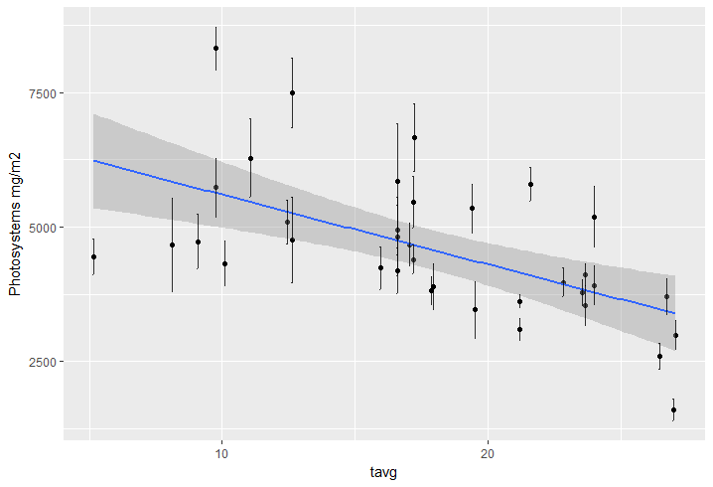

* Would be ideal to answer these q’s using avg molar ratios of photosystem proteins / Calvin cycle proteins plotted over gradients, but we need the QCONCAT standards

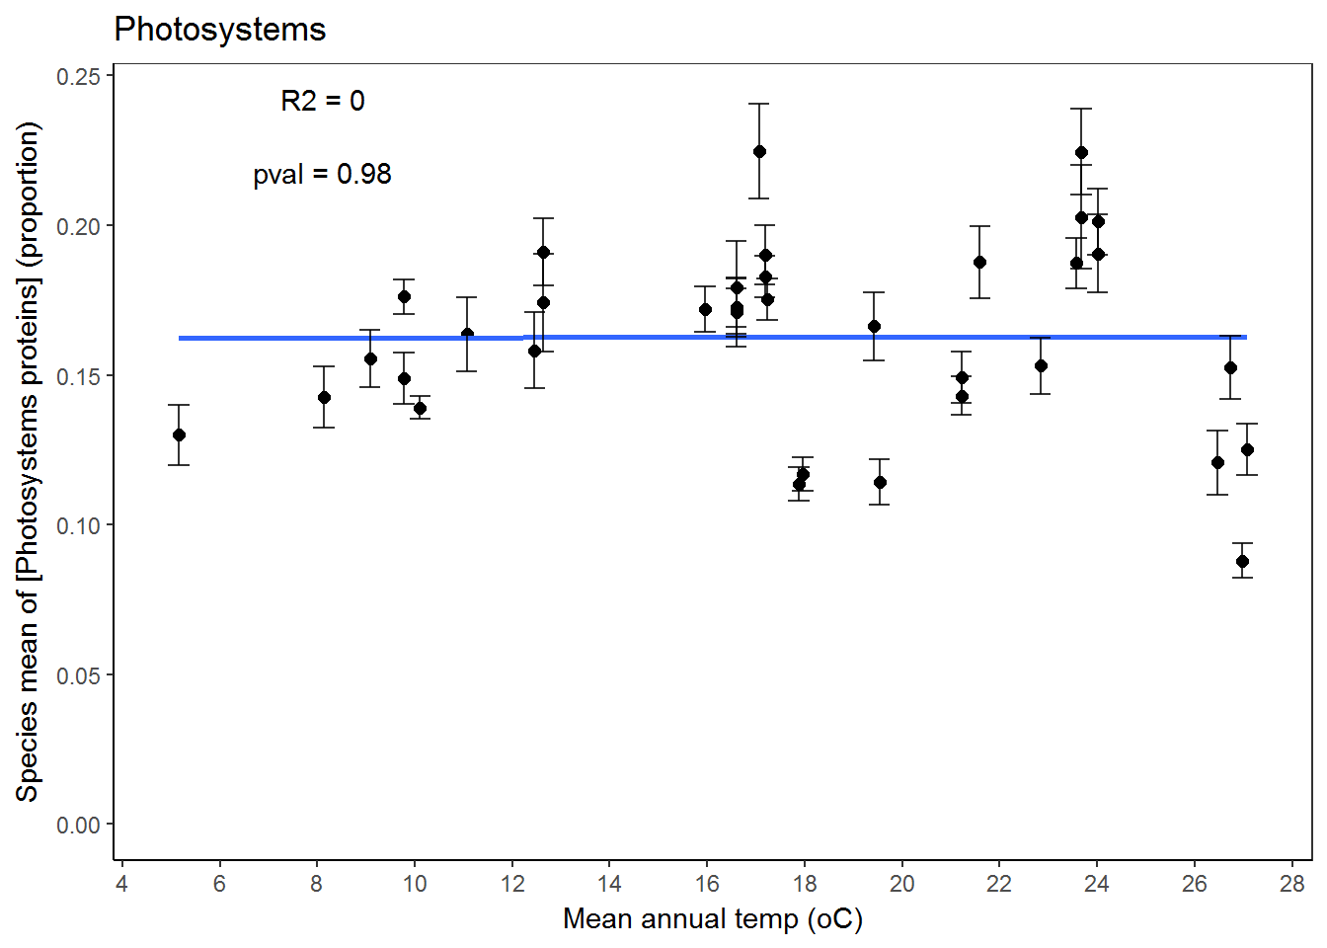

Calvin cycle variance partitioning (mg/m2):

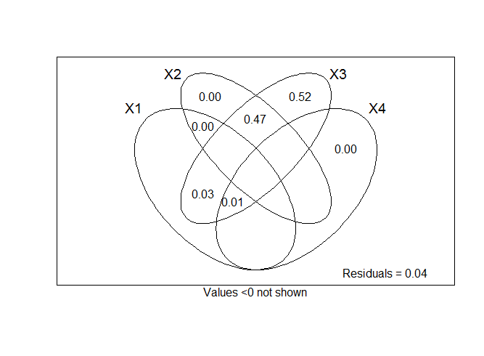

varpart(data_means$mean,

~log(leafrad_mean),

~tavg,

~total_protein_mean,

~leaf_age,

data = data_means)

Calvin cycle relative protein amounts:

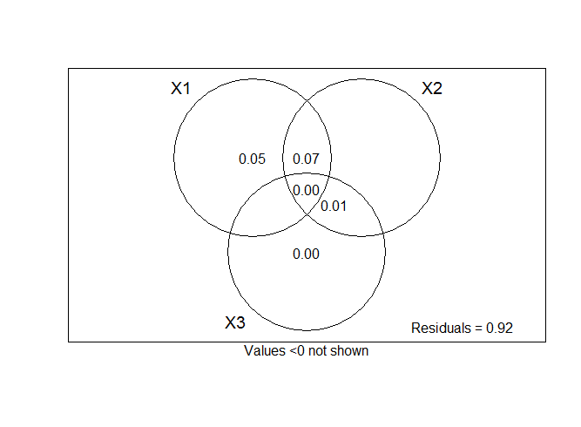

varpart(data_means$mean,

~log(leafrad_mean),

~tavg,

~leaf_age,

data = data_means)

Photosystems variance partitioning (mg/m2)

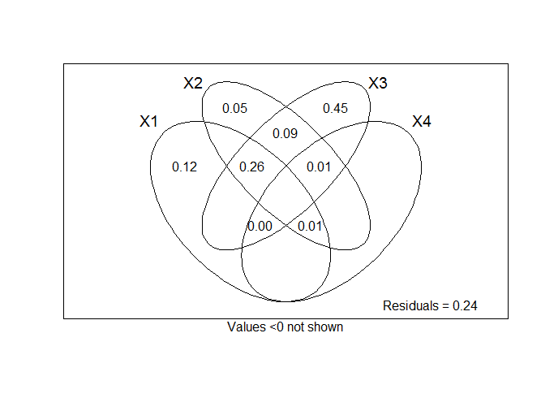

varpart(data_means$mean,

~log(leafrad_mean),

~tavg,

~total_protein_mean,

~leaf_age,

data = data_means)

Photosytems relative protein amounts

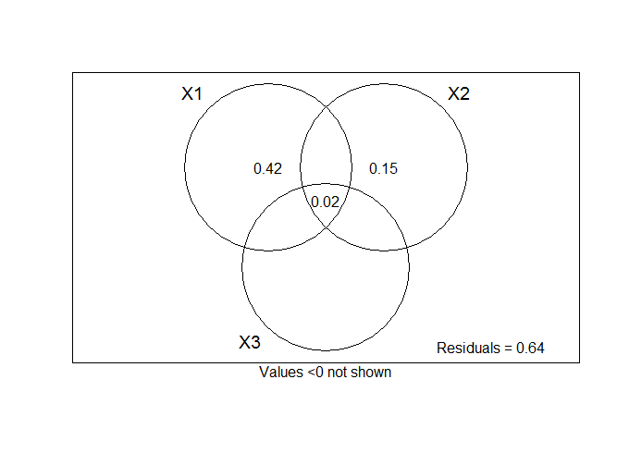

varpart(data_means$mean,

~log(leafrad_mean),

~tavg,

~leaf_age,

data = data_means)

Problem with tavg…

Other stuff:

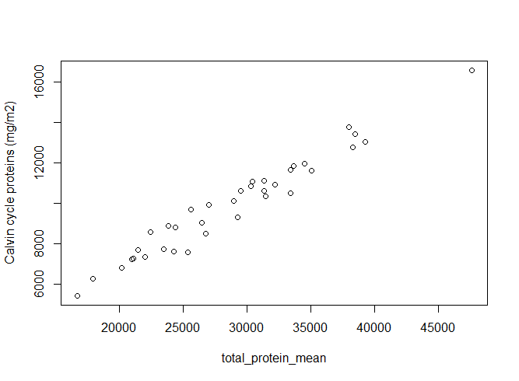

R2 = 0.95

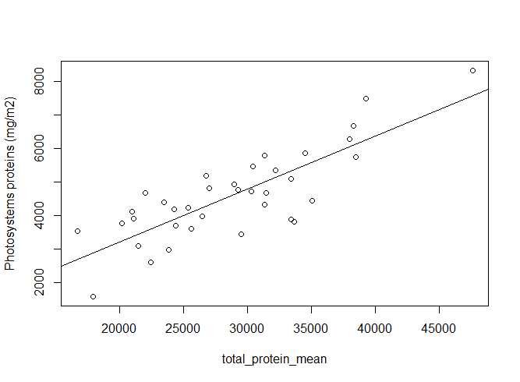

R2 = 0.66

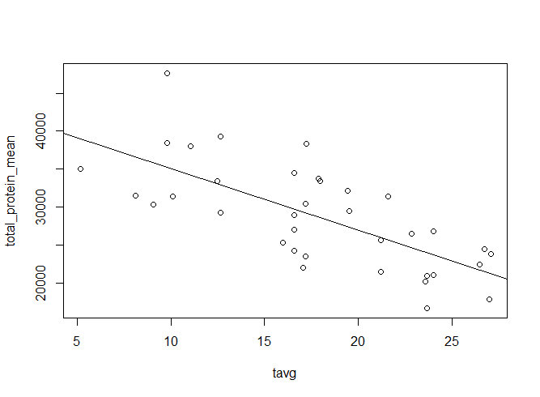

R2 = 0.48

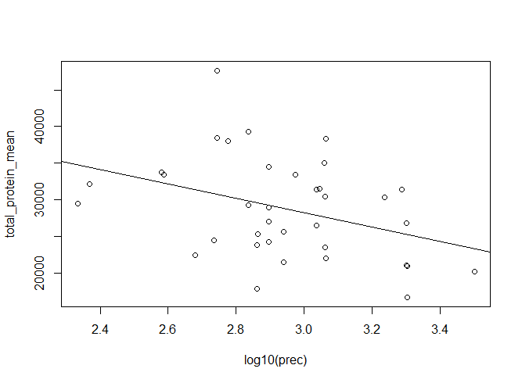

R2 = 0.11

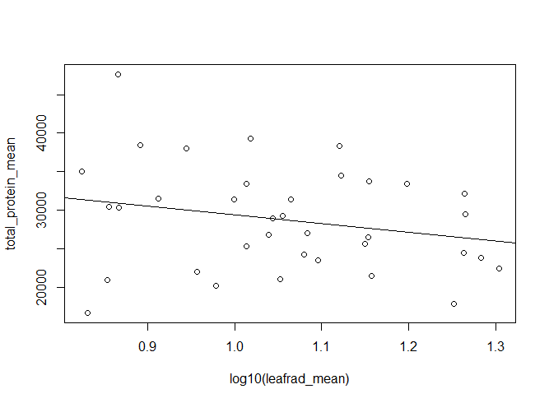

Not significant

Predictor correlations:

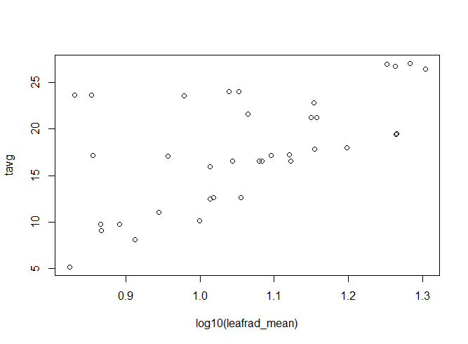

Pearson's product-moment correlation

data: data_means$tavg and log10(data_means$leafrad_mean)

t = 4.2767, df = 34, p-value = 0.0001455

alternative hypothesis: true correlation is not equal to 0

95 percent confidence interval:

0.3262900 0.7702908

sample estimates:

cor

0.5914261

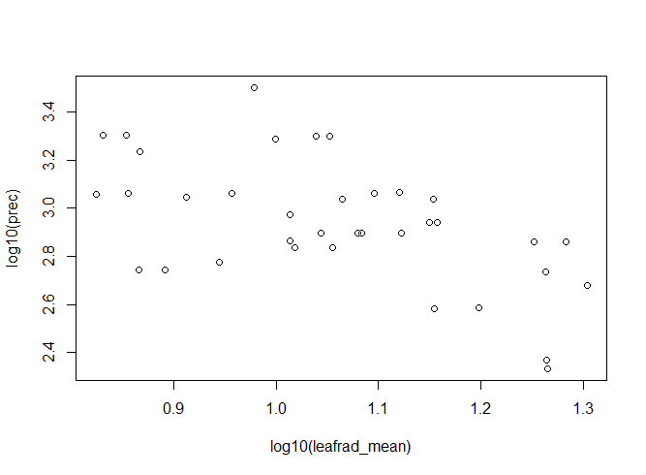

Pearson's product-moment correlation

data: log10(data_means$prec) and log10(data_means$leafrad_mean)

t = -3.9719, df = 34, p-value = 0.000351

alternative hypothesis: true correlation is not equal to 0

95 percent confidence interval:

-0.7523555 -0.2876379

sample estimates:

cor

-0.5629731

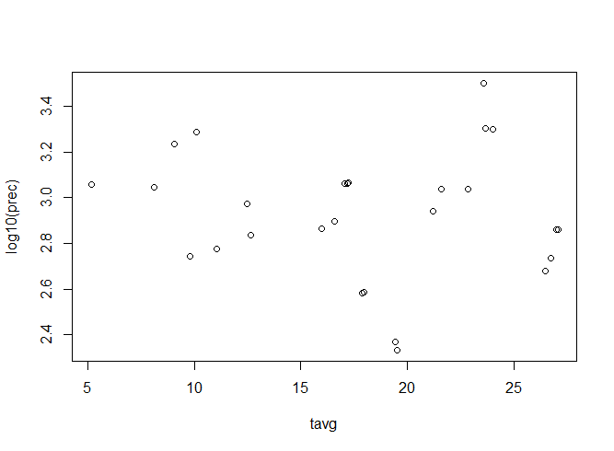

Pearson's product-moment correlation

data: log10(data_means$prec) and data_means$tavg

t = 0.28511, df = 34, p-value = 0.7773

alternative hypothesis: true correlation is not equal to 0

95 percent confidence interval:

-0.2842594 0.3714137

sample estimates:

cor

0.04883718